|  |  |
| --- | --- |
| **IT Graad 11 PAT 2024 : Healthy Living** | |
| **Naam en Van:** | **Gustav Jones** |
| **Projek Naam:** | **Boereraad** |

# **Task 1A : Define the task**

## Topic:

## Purpose of program:

## Possible solution:

## Scope:

# **Task 1B : User Stories**

| **WHO** | **WHAT** | **WHY** |
| --- | --- | --- |
|  |  |  |
|  |  |  |

# **Task 1B : User Stories - Acceptance Test**

# **Task 2 : Data Dictionary**

# **Data structures**

## Text files:

|  |  |
| --- | --- |
| **Name of text file** |  |
| **Purpose** |  |
| **Format** |  |
| **Extract of data** |  |

## Arrays:

|  |  |
| --- | --- |
| **Declaration** |  |
| **Populate arrays** |  |
| **Processing** |  |

## User defined methods

|  |  |
| --- | --- |
| **Signature** | **Explanation** |
|  |  |

# **Task 3: Database**

## Role of Database: (List of FIVE functions)

## Database design

# **Task 4 : Navigation & GUI Design**

# **Navigation**

# **GUI Design**

## User:

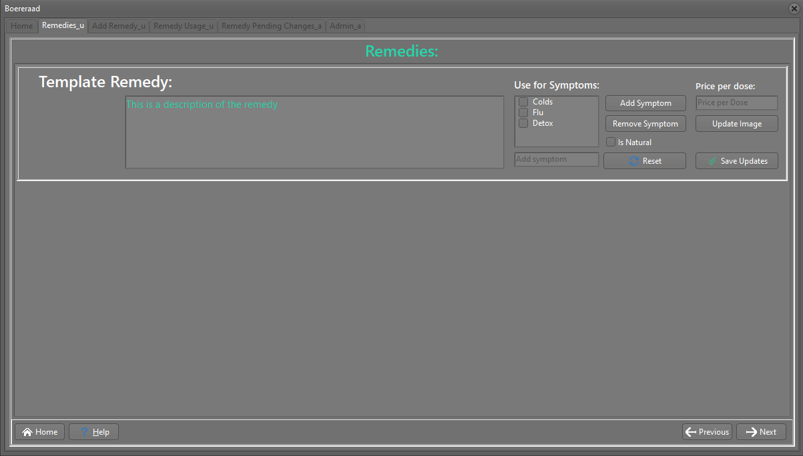

## 

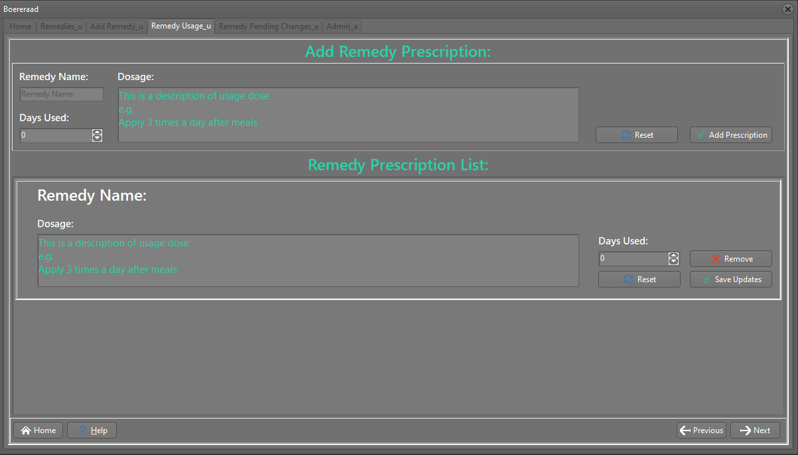

## Admin:

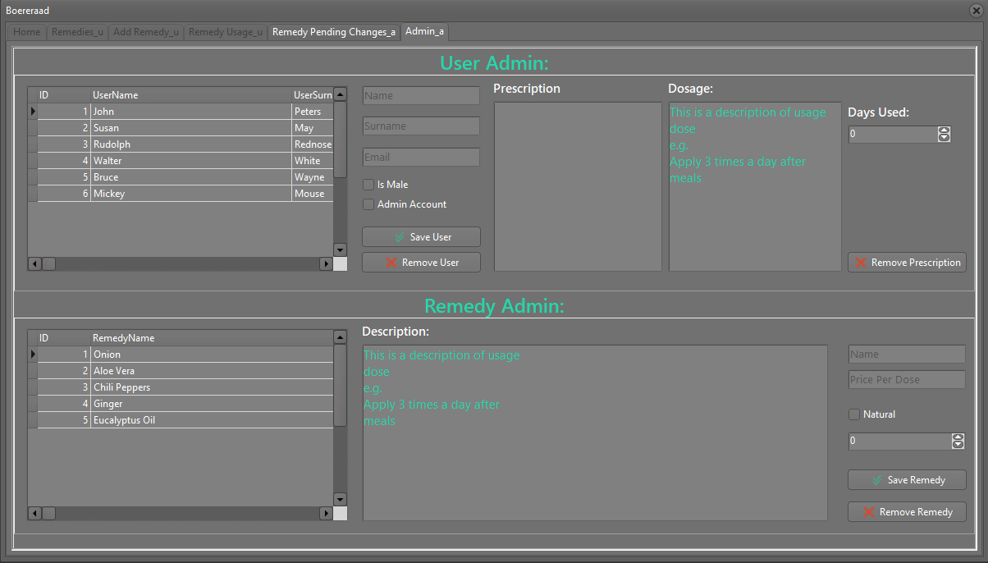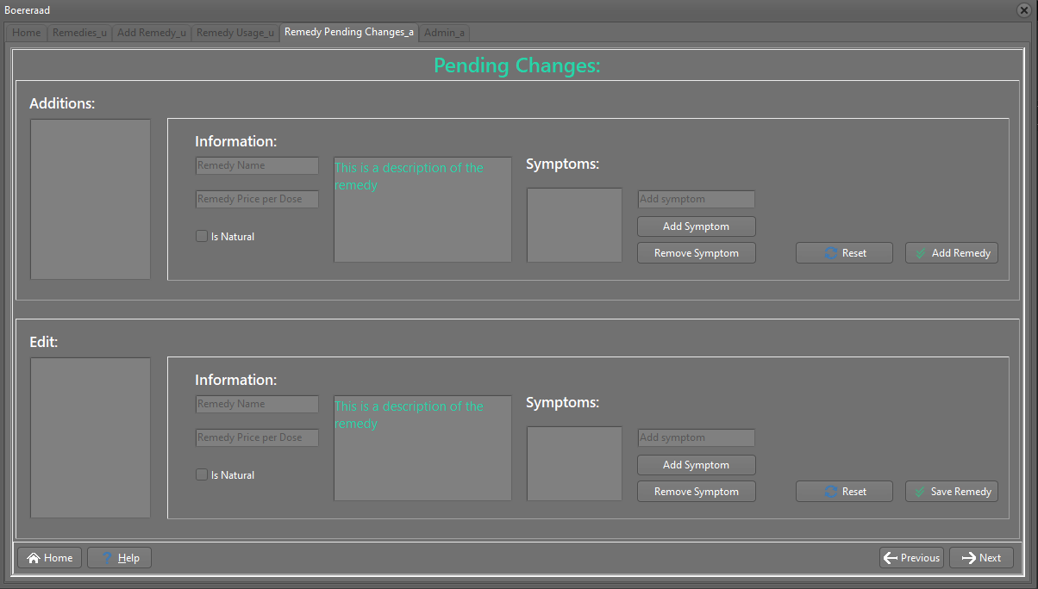

# **IPO – Software Design Tool (Task 5)**

## INPUT: tsAddRemedy

| **Source** | **Variable name & data type** | **Format (type, size)** | **GUI Object Name** | **Local/Global variable** |
| --- | --- | --- | --- | --- |
| Keyboard | sRemedyName : String | None, String Input | edtAddRemedyInputsRemedyName | Local |
| Keyboard | rRemedyPrice : Real | Currency, 2 decimals | edtAddRemedyInputsPrice | Local |
| Mouse Click | bIsNatural : Boolean | None, Boolean Input | chkAddRemedyInputsNatural | Local |
| Keyboard, Mouse Click | iEaseOfUse : Integer | None, Integer Input | sedAddRemedyInputsEaseOfUse | Local |
| Keyboard | sDescription : String | Concat Each Line | redAddRemedyInputsDescription | Local |
| Keyboard, Mouse Click | arrSymptoms : array of string | For each element in cltAddRemedyInputsSymptoms | cltAddRemedyInputsSymptoms | Local |

## INPUT: tsRemedyPendingChanges

| **Source** | **Variable name & data type** | **Format (type, size)** | **GUI Object Name** | **Local/Global variable** |
| --- | --- | --- | --- | --- |
| Mouse Click | iRemedyIndex : Integer | Selected object in lstRemedyPendingChangesAdditionsRemediesList | lstRemedyPendingChangesAdditionsRemediesList | Local |
| Keyboard | sRemedyName : String | None, String Input | edtRemedyPendingChangesAdditionsInfoName | Local |
| Keyboard | rRemedyPrice : Real | Currency, 2 Decimals | edtRemedyPendingChangesAdditionsInfoPrice | Local |
| Mouse Click | bIsNatural : Boolean | None, Boolean Input | chkRemedyPendingChangesAdditionsInfoNatural | Local |
| Keyboard | sDescription : String | Concat Each Line | redRemedyPendingChangesAdditionsInfoDescription | Local |
| Keyboard, Mouse Click | arrSymptoms : array of strings | For each element in cltRemedyPendingChangesAdditionsInfoSymptoms | cltRemedyPendingChangesAdditionsInfoSymptoms | Local |

## VALIDATION:

| **Input** | **Validation technique and description** | **Associated error message** |
| --- | --- | --- |
| edtAddRemedyInputsRemedyName | Empty Check, check if no value was given as name | Please enter a name for the remedy |
| edtAddRemedyInputsPrice | Type Check, check if input can be parsed to currency real value | Please enter a valid currency amount |
| lstRemedyPendingChangesAdditionsRemediesList | Presence Check, check if an item was selected in the listbox | Please select a Remedy from the list |
| redRemedyPendingChangesAdditionsInfoDescription | Length Check, check if the description given is within the accepted length (255) of characters | Description may not be longer than 255 characters |

## PROCESSING:

|  |  |
| --- | --- |
| **What processing will be done** | **Algorithms, formulas, etc.** |
| **List:** | **Algorithms:** |
| 1. |  |
| 2. |  |
| 3. |  |
| 4. |  |
| 5. | Algorithm 1: |
| 6. | Algorithm 2: |
| 7. | Algorithm 3: |
| 8. | Algorithm 4: |

## OUTPUT: tsRemedies

| **Data for Output** | **Format (Type, size)** | **Output Component** |
| --- | --- | --- |
| Remedy Name | String. Start with capital, with lowercase letters. | Label |
| Remedy Image | Small Resized PNG image of the remedy | Image |
| Remedy Description | Text paragraph with a max length of 255 characters | Richedit |
| Symptoms Use | A list of symptoms to use the remedy for in a listbox | ListBox |
| Natural Remedy | A boolean value to indicate if the remedy is natural | Checkbox |
| Remedy Price | A real value formatted to currency, rounded to 2 decimals indicating the remedy price | Edit |

## OUTPUT: tsAdmin

| **Data for Output** | **Format (Type, size)** | **Output Component** |
| --- | --- | --- |
| User DB Information | All user records saved in the database sorted by rows with columns as fields selectable to display in other controls | DBGrid |
| User Name | Display the user record name as a string | Edit |
| User Surname | Display the user record surname as a string | Edit |
| User Email | Display the user record email as a string | Edit |
| User Gender | Display the user record gender as a boolean. True if male, false if female | Checkbox |
| User Type | Display the user record type as a boolean. True if Admin, False if only User. | Checkbox |
| User Prescriptions | Display the user record connected prescriptions from the database in a list as strings | Listbox |
| Prescription Dosage | Display the dosage of the selected prescription as a string | Richedit |
| Prescription Days Used | Display the amount of days a prescription was used | SpinEdit |